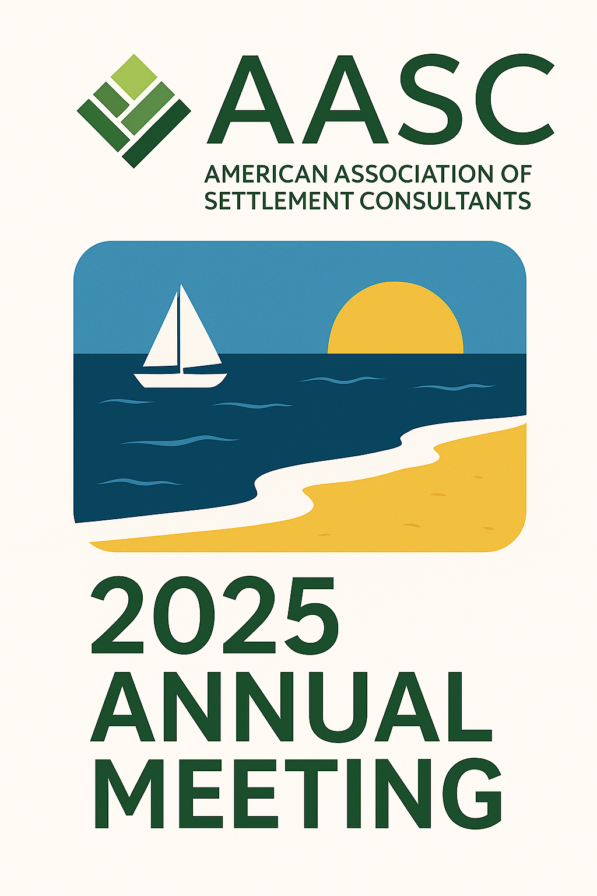
2025 AASC Annual Meeting

Wednesday, September 17

7:30-9:00pm Opening Reception

Thursday, September 18

8:15-9:00am Breakfast

9:00-9:15am Opening remarks & welcome

9:15-10:00am Rapid Fire Roundtable: Answers to Questions Every Settlement Consultant Wants to Know
Louis Masry-Quest Settlements
Tanis Kelly-Sage Settlement Consulting

10:00-10:20am Improving the Client Experience: Insights from the MetLife Personal Injury Settlement Study

10:20-10:30am Partner Spotlight: Prudential

10:30-10:40am Partner Spotlight: Pacific Life

10:40-11:00am BREAK

11:00-11:30am Beyond the Numbers: Medicare Compliance, Trusts and Lien Collaboration Strategies for Structured Settlement Planners (Moderated by George Audi)
Stacy Scrip-Capital First Trust

11:30am-noon The Psychology of Disability: Family Impact and Second Hand Trauma
Jon Cain-Legacy Enhancement Trust
Eiszel Le & Caryn Sutherland-National Care Advisors

Noon-12:45pm Lunch at hotel

12:55-1:05pm: Partner Spotlight: New York Life

1:05-1:15pm: Partner Spotlight: Independent Life

1:15-1:50pm AASC Report

1:50-2:00pm Partner Spotlight: Assura/Structures

2:00-2:50pm The Great Settlement Swindle-An Interactive Ethics Mystery*
Randy Levine-ESS Settlement Services

2:50-3:35pm Policy Pulse 2025-Structured Settlements, Compliance Shifts, and Impacts of Federal Tax Legislation
Dave Olander-Capitol Counsel
David Vaclavik-Sage Settlement Consulting

3:30-3:45pm BREAK

3:45-4:35pm Saving Tax with Overlooked Strategies
Jeremy Babener

4:35-4:45pm BREAK

4:45-5:35pm Life Insurance in Structured Settlements: Benefits, Options, and Best Practices
Scott Freeman-Sage Settlement Consulting
Kimberly Collins-Mirena and Company Insurance Agency

6:00-8:00pm Dinner with Partner Members

8:00-11:00pm Presidential Party

Sessions in bold are seeking CE credit. 5 credits pending, including an ethics credit.

*Ethics credit

