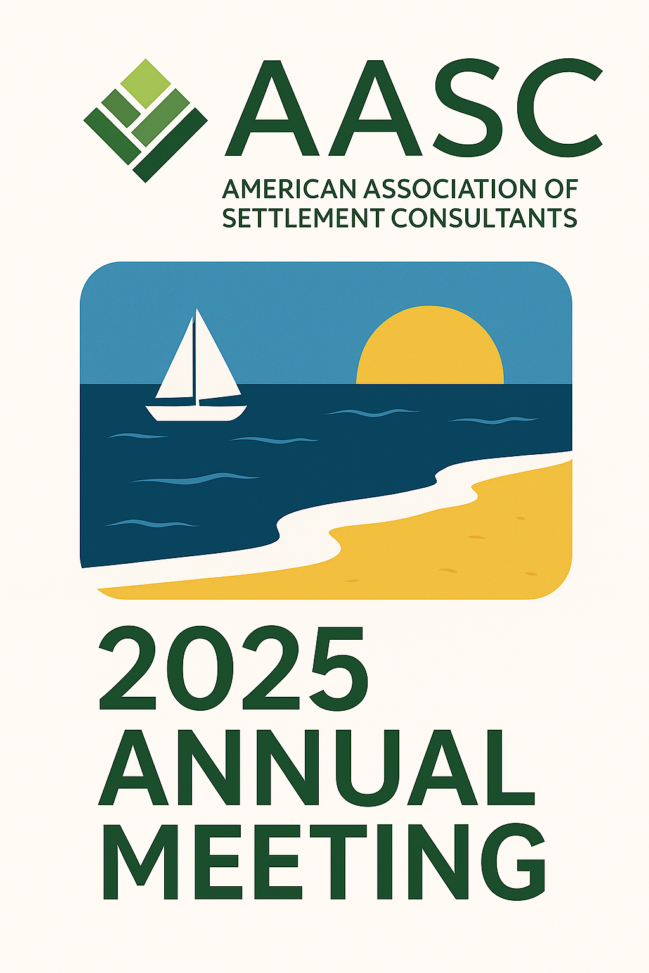
2025 AASC Annual Meeting

Wednesday, September 17

8:00-9:30pm Opening Reception (Pacific Terrace)

Thursday, September 18
Educational sessions will be in the Platinum Ballroom

8:15-9:00am Breakfast (Sunset Terrace)

9:00-9:15am Opening remarks & welcome
AASC President Louis Masry

9:15-10:00am Rapid Fire Roundtable: Answers to Questions Every Settlement Consultant Wants to Know
Louis Masry-Quest Settlements
Tanis Kelly-Sage Settlement Consulting
Brian Schachter-ESS Settlement Services/Sage

10:00-10:20am **Improving the Client Experience: Insights from the MetLife Personal Injury Settlement Study (Moderated by Tanis Kelly)
Toni Griffin-MetLife

10:20-10:30am *Partner Spotlight: Prudential

10:30-10:40am *Partner Spotlight: Pacific Life

10:40-11:00am BREAK

11:00-11:30am Beyond the Numbers: Medicare Compliance, Trusts and Lien Collaboration Strategies for Structured Settlement Planners (Moderated by George Audi)
Stacy Scrip-Capital First Trust
Randy Levine-ESS Settlement Services

11:30am-noon The Benefits of Benefits
Jonathon Cain-Legacy Enhancement Trust
Caryn Sutherland-National Care Advisors
Noon-12:45pm Lunch (Sunset Terrace)

12:45-12:55pm *Partner Spotlight: American National Insurance Company

12:55-1:05pm: **Partner Spotlight: New York Life
Julia Hermann, Global Market Strategist

1:05-1:15pm: *Partner Spotlight: Independent Life

1:15-1:50pm AASC Report

1:50-2:00pm *Partner Spotlight: Assura/Structures

2:00-2:50pm The Great Settlement Swindle-An Interactive Ethics Mystery^
Randy Levine-ESS Settlement Services

2:50-3:35pm Policy Pulse 2025-Structured Settlements, Compliance Shifts, and Impacts of Federal Tax Legislation
Dave Olander-Capitol Counsel
David Vaclavik-Sage Settlement Consulting

3:30-3:45pm BREAK

3:45-4:35pm Saving Tax with Overlooked Strategies (Moderated by Brian Schachter)
Jeremy Babener-Structured Consulting

4:35-4:45pm BREAK

4:45-5:35pm **Life Insurance in Structured Settlements: Benefits, Options, and Best Practices
Scott Freeman-Sage Settlement Consulting
Kimberly Collins-Mirena and Company Insurance Agency

6:00-8:15pm Dinner with Partner Members

8:30pm-midnight Presidential Party for Louis Masry
Jimmy O’s
225 15th Street
(The comedy performance may include adult themes and strong language that some guests may find offensive. Attendance is at your discretion.)

Sessions in bold are seeking CE credit. 5 credits pending, including an ethics credit.

^Ethics credit
**Virtual presenter
*Consultants & case managers only

