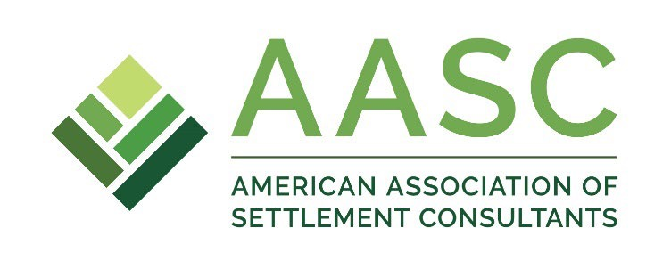
2024 AASC Annual Meeting

The Adolphus Hotel
1321 Commerce Street, Dallas, TX

* Times are Central
Continuing education credit pending state by state.

Tuesday, March 19

1:00pm Continuing Education Committee meeting
2:00pm Membership Committee meeting
3:00pm Legs & Regs Committee meeting
4:00pm PAC meeting
4:45pm AASC Board meeting
6:00pm-7:30pm: Opening reception

Wednesday, March 20
*EXHIBIT DAY FOR PARTNERS*

8:00am-8:30am: Breakfast

8:30-8:45am: Welcome and introductions

8:45-10:15am: Understanding unique state and regional trends
Speakers: Joanna Wynes, Brian Schachter, Tanis Kelly, Dan DiVico, (Texas rep)

10:15-11:00am: Vetting Pooled Trust Companies
Speakers: Andrea Metcalf, Joanna Wynes

11:00am-12:00pm: Ethics for Settlement Consultants
Speaker: Len Blonder

12:15-2:00pm: Lunch on your own

2:00-2:30pm: AASC Report

2:30-3:30pm: Case Studies on the Bookends of Life: Perspectives from
Professionals
Speaker: George Audi

3:30-4:30pm: Missed Tax Strategies at Settlement
Speaker: Jeremy Babener

4:30-4:45pm: BREAK

4:45-5:30pm: Legislative Update from Capitol Counsel
Speaker: Dave Olander

5:30pm-6:30pm: AASC PAC reception

6:30-8:30pm: (Partner dinners)

8:30-11:30pm: President’s party
Punch Bowl Social
2600 Main Street, Dallas
VIP Bowling Room

Thursday, March 21

8:30am-9:00am: Breakfast

9:00-10:00am: Max Funded IUL: Tax Free Retirement Income Strategies
Speaker: Maurice L. Naylon, III

10:00am-noon Informational sessions on annuities, trusts, and emerging products

