**2025 AASC Annual Meeting**

**Thank you to our partners for their generous support as Annual Meeting sponsors!**

**Diamond Partner:**

**Gold Partner:**

**Silver Partners:**

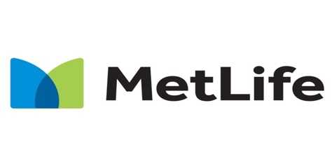 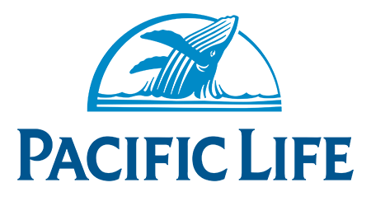



**Bronze Partners:**

